RESUME

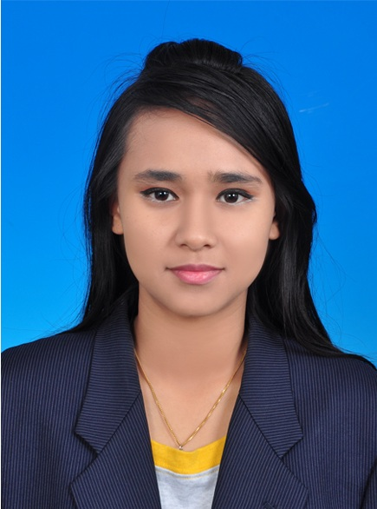

Personal Details

Name : PRIYANUT A/P MANIT
Nric : 911231-09-5092
Sex : Female
Age : 24
Date of Birth : 31 Dec 1991
Race : Siamese
Nationality : Malaysian
Marital Status : Single
Religion : Buddhist
Current address : G2-1-4, Kuarters IPD SPU,
Jalan Jambu Laut,
13200 Kepala Batas,
Pulau Pinang.

CONTACT INFORMATION
Mobile : 013-4216014
Email Add. : priyanutthamsuwan@gmail.com

Academics Background

SEPT 2013 – MALAYSIA NORTHERN UNIVERSITY (UUM)
PRESENT

Bachelor in Business Administration with Honours
• Obtained CGPA score of 2.95

JAN 2010 - POLYTECHNIC (Ungku Omar Polytechnic)
DEC 2012
Diploma in civil engineering
• Obtained CGPA score of 3.19

JAN 2007- Sek. Men. Keb. Kepala Batas
DEC 2008

SPM
- 1 A2- Mathematics
- 2 3B- Malay Language and Visual Arts education
- 2 4B- Moral education and History education
- 1 5C- Science
- 1 6C- English
- 1 7D- Business study

Working Experiences

Period : March 2013 - Present
Work Place : Dell Global Business Center Sdn.Bhd.
Position : TH / SA CMG (Call Management Group)
Task : Accept call from customer Thailand, get customer detail,
know what customer problem, help them to order spare part,
transfer customer to the sale department, government,
technical support and etc.

Period : Sept 2012 - Oct 2012
Work Place : Jusco Jaya Sri Kinta
Position : Promoter (ABC Shoe wear department)
Address : Jusco Jaya Sri Kinta Ipoh, Perak.
Tel : 05-5457802

Period : May 2012 - June 2012
Work Place : KFC Gunung Rapat
Position : Cashier
Address : KFC Gunung Rapat Ipoh, Perak.
Tel : 05-3115540

Period : Jul 2011 – Dec 2011
Practical Training : Bertam Properties Sdn. Bhd.
Address : No 1, Jln Dangangan 1 Pusat Bandar Bertam Perdana,
13200 Kepala Batas, Pulau Pinang.
Tel : 04-5782017
Tasks : Exposed to preparing progress report, data processing and
programming, calculation for the percent of week, learning
about the management project and attending for the cube test
and compacting test.

Period : March 2009 - Dec 2009
Work Place : RBK Servis Station Petronas Bertam, Kepala Batas
Position : Cashier and Promoter
Address : Lot 2081 & 6163 MK 6, Bertam Perdana,
13200 Kepala Batas, Pulau Pinang
Tel : 04-5783094

Co-Curriculum

- Participation in Project Unity 6 in 1 Series 1/2015 on 23th March 2015 (UUM)
- Participation in Road safety programs with road safety department (JKJR) SIRIM and Universiti Utara Malaysia on 23 September 2014 (UUM)
- Participation in Project 6 in 1 on 10th March 2014 (UUM)
- Participant in Fun Run 2014 on 7th March 2014 (UUM)
- Participation in Kachi Aerobics 2014 on 7th March 2014 (UUM)
- Student Leadership Camp (SLC) 2014 on February 2014
- Participation in training program to transform the country’s Universiti Utara Malaysia students on Feb 2014 (UUM)
- Banquet subcommittee bureau chief co subunit 2014 (UUM)
- Participation in Northern Tour Programme (UUM)
- Participation in courses ‘We are the host’ on Dec 2013 (UUM)
- Publicity bureau committee member Kachi Night Run 2013 on Nov 2013 (UUM)
- Treasurer of the small subunit curriculum committee 2013 (UUM)
- Build and Break Competition DEC’11 on March 2012 (Polytechnic)
- Participant orientation week facilitator JAN session 2010 (Polytechnic)
- Karnival Sukan Jabatan Kejuruteraan Awam session Dec 2011 on March 2012 (Polytechnic)
- Facilitator orientation week DEC session 2011 & 2012 (Polytechnic)
- A member of Jabatan Pertahanan Awam
- AJK Koperasi Ungku Omar Polytechnic
- Polybriged of Polytechnic
- Deputy of the school in the zone level Kepala Batas in Netball 2008 (Smkkb)
- Songkran queen contest state level Pulau Pinang 2008
- Kem Gaya Hidup Rakan Muda Daerah Seberang Perai on 30 Nov – 4 Dec 2007
- Program Komuniti Belia Remaja Y2Y Peringkat Dun 22 Nov – 24 Nov 2007
- Volunteer base course Rakan Muda on 17 Nov – 21 Nov 2007
- BM Hiking Hutan Lipur Cherok To’Kun on 2005
- Pengawas library 2001-2003 (SKCB)
- Secretary of science and mathematic clubs 2002 (SKCB)

Language

- Bahasa Malaysia (Good in both written and spoken)
- English (Fair in written and spoken)
- Thai (Spoken only)
- Mandarin (Fair in written and spoken)

Skills/Strengths

- Computer literate, knowledge in Microsoft word, Excel, PowerPoint and AutoCADD.
- Able to work in new environment.
- Hardworking, responsible and punctual able.
- Willingness to work hard when the occasion demands
- Driving license (D and B2 class)

Honours and Awards

- Recipient Dean Award of Polytechnic Premier Ungku Omar in 2012
- Obtain excellence as top ten students in form 5 2008 (SMKKB)
- Students who attend full during session of 2007 (SMKKB)
- Achievement in introductions to computers Microsoft Office 2003 – Expert Web Design using HTML Adobe Photoshop Macromedia Flash 2005 (SMKCB)
- Achievement in Microsoft Word 2000, Introduction to Internet and Networking and Microsoft PowerPoint 2000 in 2004 (SMKCB)

Relevant Courses Taken

- BJMQ 3013 – Quality Management
- BPMN 3023 – Strategic Management
- BPMN 3103 – Seminar in Management Thinking
- BEEB 1013 – Principles of Economics
- BKAL 1013 – Business Accounting
- BPIN 3053 – Management Information System
- BPME 1013 – Introduction to Entrepreneurship
- BPME 2013 – Entrepreneurial Behaviour and Skill
- BPME 2023 – Creativity and Innovation
- BPME 2043 – Business Plan
- BPME 3023 – Franchise Business Management
- BPME 3033 – E-Commerce
- BPME 3073 – Entrepreneurship
- BPMM 1013 – Principles of Marketing
- BPMM 3133 – Retailing Management
- BPMN 1013 – Principles of Management
- BPMN 2023 – Organizational Bahavior
- BPMN 3123 – Management Ethics
- BPMN 3143 – Research Methodology
- BSMH 2013 – Human Resource Management
- BWFF 2033 – Financial Management

Coordinator

Prof. Madya Dr. Siti Zubaidah Othman
Coordinator Practicum
04-9286605
zubaidah@uum.edu.my

